Project Name- Junkyard Physics

Project Proposal by- Jo Jones, K1107602

Date- 28/09/13

Project Supervisor- Hope Caton

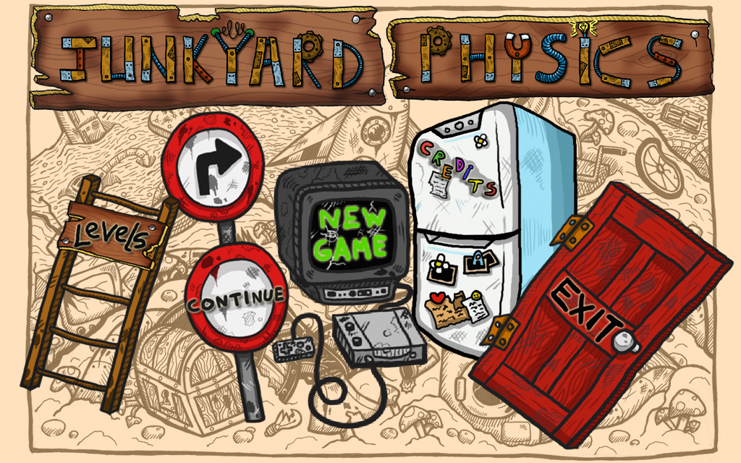

Junkyard Physics

Project Proposal

Contents

The Project 2

What’s been done so far 2

What’s going to be done 3

User Interface 3

User Experience 4

Reward and Punishment 4

Game Mechanics and Functionality 4

Tools and Technology 5

Appendix 6

Time Line of Project 6

Literature review 6

References 7

# The Project

This game was created to test if games can be used to teach physics. Through a research internship it was found that although the game needed improvements, people believed that it would be a good way to learn physics. Below is what has gone into the game so far.

## What’s been done so far

* Basic game mechanic is implemented
* Basic Gui elements have been implemented
* Nine levels have been created using both thrust and impulse
* A win condition has been created as well as the ability to move onto the next level
* Player can continue where left of if game hasn’t been stopped
* Art assets have been added on all current components
* Theme tune has been added
* Sound effects have been added to several objects
* Questions can be asked of the player in gate screen levels, there are currently 3 levels of this type.
* A video of the original game - <http://www.youtube.com/watch?v=e-6GYNnCM7M>

People involved and their roles:-

* Jo Jones (Producer, Designer, Programmer)
* Initiated the game play idea
* Set deadlines and pulled together the group
* Created Materials and Textures using Rachael’s art files
* Created source for the GUI and implemented the GUI

- Including created buttons and making them light up

* Created most of the levels using Unity editor
* Implemented sounds
* Sonia Paul (Programmer)
* Lead programmer (Non GUI source code is Sonias’)
* Programmed game mechanics and world controllers

- Including level flow

* Programmed the tutorial
* Created Materials and Textures using Rachael’s art files
* Created some of the levels using Unity editor
* Implemented theme tune
* Rachael Gater (Artist)
* Created all concept art and storyboards
* Created all digital art as, jpg, png or tif
* Jameson Bell (Sound Engineer)

- Created Junkyard Physics Theme mp3

- Created all sound effects in WAV format

## What’s going to be done

Junkyard Physics has been tested for feedback at several locations. Several points have arisen throughout the testing.

First that the level design needs more definition between the foreground (interactive) objects and the background objects.

2. The tutorial is confusing even with extra instruction.

3. The game should be on a tablet.

Below is a list of all the improvements that will be made. Some are based on feedback from players and some is from observations when watching others play. A few new features will be made to “Juice” up the game. This game will follow the game development process as proposed by Sid Meier. (14)

* Players should have the fun, not the programmer or designer
* Begin the game with great opening minutes
* Great gameplay is a stream of interesting decision that the player must resolve
* Put the player in a position where he/she is the hero
* His development process:
  + Prototype
  + Play the game for a while and get the basics right
  + Now get other people to look at the game
  + Meticulously observe the player
  + Constantly reward the player in the game
  + Throw in new testers
  + Make the game harder until the players beg for mercy

The current version of the game has already followed many of these principles and it will continue to be followed. The game will be made more fun, the player will become the hero of the nice rabbits and there will be a cinematic to hook in the player. The game will also be meticulously tested once the new additions are fully working.

### User Interface

* Deploy the game onto Android tablet.
* Create a new levels page to display the number of nuts collected per level and enable easy level access.
* Improve the main menu to ensure it works on all resolutions and can be edited when the mini game has been unlocked. The main menu needs to draw the player in and so it needs to be juiced up.
* The current in game buttons are not comprehendible for easy interaction by the player. They blend too much into the background and so should be made to stick out on the page. The code needs edited to improve efficiency and ensure support for all resolutions.
* The thrust and impulse selection is very confusing and so will be changed so that you can select a rocket or a boot and it glows the colour of the arrow being drawn.

### User Experience

* Include background animations to make the scene more interesting. Such as falling rubbish, moving clouds and changing weather.
* It can be difficult to tell what items the ball will interact with and what is background decoration. To improve this the fencing will be changed and all decoration will be done with various dark coloured pieces of rubbish. The pieces that the ball will interact with will be bright coloured and may have a glow.
* To give another level to the game a secret door will be placed in a random level which if the player presses they will unlock a mini game, the mechanics are explained later.
* The game will include a story of good rabbits versus evil rabbits to portray this a cinematic will be used at the start of the game. The nice rabbit will be the in game assistant and provide the player with the means to capture the evil rabbits this includes the impulse boot and the thrust rocket. Therefore the nice rabbit will explain how the objects work through cinematics.
* 60 levels will be created. 20 impulse levels, 20 thrust levels and 20 using both impulse and thrust. This levelling style with give the player plenty of opportunity to learn the game mechanic for both thrust and impulse before they are put together to create harder levels.

### Reward and Punishment

* Current rewards are you collect the nuts and they fall into an empty jar. This will be added to, the jar will fill up as you complete levels. Then once the jar is full (at the end of a level type) you get a shiny bike for one of the nice rabbits to ride about. This will be the long term rewards. In the short term the player will be reinforced when the evil rabbit looks grumpy and angry at being tramped. There will also be a mini celebration on the level complete page. The nice bunny will do a little dance, there is a fan fair and hopefully some confetti!
* Evil rabbit supplies the punishment. When you fail a level the evil rabbit sticks out his tongue at you. A “waawaaawaaaaa” sound effect is also played. To improve this animations of the nice rabbit crying will be displayed as well as the evil rabbit cheering and dancing. The in game reinforcement of failing will be that the rabbit escapes from the cage.

### Game Mechanics and Functionality

* The tutorial built into the game currently relies on people reading a large amount of instruction. This will be changed to a pictorial tutorial that can be accessed on the home page. As well as this small animations will be created that will be triggered by certain points of game play within the first level of each level type (impulse, thrust and both impulse and thrust).
* The levels can be quite difficult for people getting used to the new type of mechanic this game contains. To help combat frustration at the levels a hint will be given after 3 failed tries of the current level. This will be presented by the nice rabbit saying something. For example “Remember gravity will drag the ball back to earth”.
* To continue to help with the game play a ghost arrow of the previous arrow position will be shown so that the player has a reference as to what they did before.
* Saving and loading will be added to the game as 60 is a lot to complete in one go. It also gives people the opportunity to return to the game at a later date and not have to start from the beginning.
* The number of nuts collected on each level will be saved and totalled to see if the player has collected enough to move onto the next set of levels. The reason for a numbered collection will be that the nuts are used as bait to attract the evil rabbits to the traps. These nuts will become harder and harder to collect as they will move around and so the player will have to time their moves carefully.
* Mentioned before the evil rabbit will be captured. To enable this in game play the player will release a cage switch with the ball instead of pressing a button. Some other capturing ideas are to have a net on the end of a paddle and the player must hit the end of the paddle to activate the net. Later on in level the evil rabbit will move about the level and so the player must perfectly time their move.
* New level designs will be included, such as underground levels as if the player is exploring the evil rabbit warren.
* The mini game will be in the style of Temple Run, however you will be the nice rabbit on a bike and bolts will replace the coins for the player to collect. The player will have to avoid piles of rubbish whilst running away from an evil rabbit. (This is an optional extra if time allows, if the mini game isn’t made then a hidden room will be created instead.)

# Tools and Technology

Unity was chosen because it has become widely used in industry. Knowing how to use Unity helps to improve employability in the current game industry. Unity provides the physics for the game as well as an environment to make levels easily through the drag and drop editor. Unity will also be used to create the cinematics as multiple animations can be played at one time. Junkyard is coded in C# using Visual Studio as the coding environment. Visual Studios will be used in place of Mono Develop as the environment is preferred. There are many key combinations that can be used to tidy code formatting that are not present in Mono.

The art assets have been created in PhotoShop and will be redrawn and improved using both PhotoShop and Illustrator. These programmes will be used by an artist who is providing the project with all of the art assets. The assets that will be used for the animation sequences will also be drawn in Illustrator and saved in separate files for use in Unity. All art will be saved in png format with transparency to ensure good quality on the textures.

This game will be deployed onto an android tablet. The Samsung Tab 3 – 8 inch will be used to test the game during development. An 8 inch tablet was chosen to enable testing on an average screen size that will be used by players. This will assist with level design as the levels need to be clear on small screens and not stretched out on big screens. Samsung Tab 3 runs the latest version of Android which means the game can be optimised for the newest Android technology.

# Appendix

# Time Line of Project

In PDF ProjectSchedule supplied separately. The time it takes to complete the tasks has been estimated. Some tasks may take longer to complete and other course work may take precedence at some times throughout the year. I have also gone it to a lot of detail so that I remember all of the new features that I have decided upon. This will also prevent feature creeping.

# Literature review

Game based Learning

Recent research focused on the ability to use games in areas other than for pure entertainment (Subrahmanyam & Greenfield, 1994). The context into which this present research was conducted was first of all the wider context of gamification and secondly the more specific concept of games in the educational process. Gamification has been shown to be of help in several fields such as at work, marketing and learning (Karl Knapp 2012). More specifically, gaming has been shown to be beneficial to the educational process (de Freitas 2006). This is because learning has been shown to be most effective when it contains elements which also exist to a high degree within a gaming mechanic. These include the learning experience being situated, active, problem-based and providing immediate feedback (Boyle, E.A, Connolly, T.M, and Hainey.T, 2008).

Game programming software

There is much literature covering the basics of how to use Unity`s editor. These are supplied by Unity themselves as well as blogs by users of unity. The scripting reference provided by Unity covers all the functions built in to the Unity engine as well as some examples of how to use them. Again more examples and uses of functions can be found through Unity user blogs. These blogs also supply answers of how to create simple and some complex game mechanics in Unity. Although most of the examples are in JavaScript, this can be easily translated in C# for use in this project. YouTube is also a source of knowledge for Unity and general game creation. There can be detailed tutorials of how to create basic games and how to add juicy features such as animations to the game (15).

# 

# References

1. <http://nanodome.wordpress.com/2011/08/09/the-short-prehistory-of-gamification/> - accessed 20/07/2013
2. <http://www.reveal-thegame.com/> - accessed 20/07/2013 - L’OREAL – François de Wazières
3. <http://www.education.gov.uk/schools/teachingandlearning/curriculum/primary/b00199179/science-> Accessed 03/08/2013 - Crown copyright 2013
4. The Gamification of Learning and Instruction: Game-based Methods and Strategies for Training and Education - Pfeiffer; 1 edition (May 1, 2012)
5. [http://www.journals.elsevier.com/computers-and-education - 2013 Elsevier B.V](http://www.journals.elsevier.com/computers-and-education%20-%202013%20Elsevier%20B.V).
6. De Freitas, S. (2006). Learning in immersive worlds.- Joint information systems Committee
7. Boyle, E.A., Connolly, T.M., and Hainey,T.(2008) The role of psychology in understanding the impact of computer games.- Entertainment computing.
8. Ogletree, S.M & Drake, R (2007). College students video game participation and perceptions: gender differences and implications.
9. Anderson, C.A (2004). An update on the effects of playing violent video games. Journal of Adolescence.
10. Anderson, C.A & Bushman, B.J, (2001). Effects of violent video games on aggressive behaviour.
11. Subrahmanyam & Greenfield, (1994). Effect of video game practice on spatial skills in girls and boys.
12. <http://www.forbes.com/sites/johngaudiosi/2013/03/11/rovio-execs-explain-what-angry-birds-toons-channel-opens-up-to-its-1-7-billion-gamers/>
13. <http://docs.unity3d.com/Documentation/ScriptReference/>
14. <http://www.cs.tufts.edu/comp/50GD/lectures/07.php>
15. <http://www.youtube.com/watch?v=Fy0aCDmgnxg>